MLP model Accuracy

WITH SVOL

R2 score:

0.9390598471354223

Scatter plot

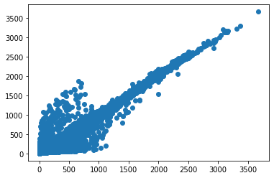

R2 score with bs_call

0.9426345334131156

With Normal vol

R2 score:

0.9402648495883987

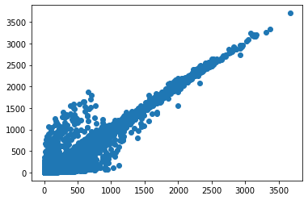

R2 score with blackscholes

0.9426345334131156

Model: "model"

__________________________________________________________________________________________________

Layer (type) Output Shape Param # Connected to

==================================================================================================

input_1 (InputLayer) [(None, 20, 1)] 0

__________________________________________________________________________________________________

sequential (Sequential) (None, 8) 6224 input_1[0][0]

__________________________________________________________________________________________________

input_2 (InputLayer) [(None, 4)] 0

__________________________________________________________________________________________________

concatenate (Concatenate) (None, 12) 0 sequential[0][0]

input_2[0][0]

__________________________________________________________________________________________________

dense (Dense) (None, 100) 1300 concatenate[0][0]

__________________________________________________________________________________________________

batch_normalization (BatchNorma (None, 100) 400 dense[0][0]

__________________________________________________________________________________________________

leaky_re_lu (LeakyReLU) (None, 100) 0 batch_normalization[0][0]

__________________________________________________________________________________________________

dense_1 (Dense) (None, 100) 10100 leaky_re_lu[0][0]

__________________________________________________________________________________________________

batch_normalization_1 (BatchNor (None, 100) 400 dense_1[0][0]

__________________________________________________________________________________________________

leaky_re_lu_1 (LeakyReLU) (None, 100) 0 batch_normalization_1[0][0]

__________________________________________________________________________________________________

dense_2 (Dense) (None, 100) 10100 leaky_re_lu_1[0][0]

__________________________________________________________________________________________________

batch_normalization_2 (BatchNor (None, 100) 400 dense_2[0][0]

__________________________________________________________________________________________________

leaky_re_lu_2 (LeakyReLU) (None, 100) 0 batch_normalization_2[0][0]

__________________________________________________________________________________________________

dense_3 (Dense) (None, 1) 101 leaky_re_lu_2[0][0]

==================================================================================================

Total params: 29,025

Trainable params: 28,425

Non-trainable params: 600

___________________________________________________________________________________

LSTM)

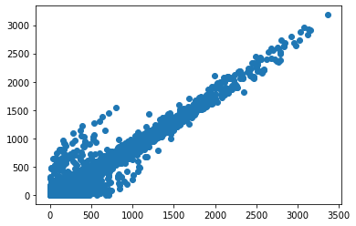

Y_test vs y_pred

MAE-:67.24218145483937

MSE-:12372.700947288793

BlackScholes-:

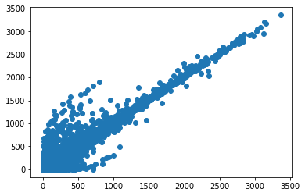

MAE-:39.1590574699689

MSE-:9042.55910966539

LSTM(with resources):

print(reg.score(x,y)):0.9457331686671906

MAE:84.50230266866564 , MSE: 16523.330198358926

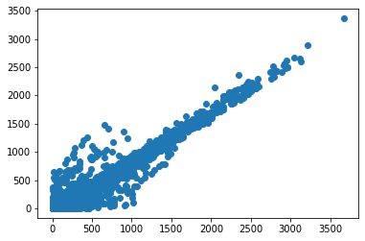

MLP with VOL

print(reg.score(x,y),mae,mse)

0.9481883559940043 48.89514604119551 8869.770818254554

Explained_VAR=-0.06683200134715994

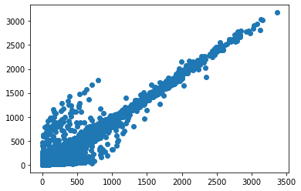

Blackscholes

print(reg_bs.score(x_bs,y_bs),mae_bs,mse_bs)

0.9490160095354201 39.1590574699689 9042.55910966539

Explained_VAR_bs= 0.02993812146705732



MLP with SVOL

print(reg.score(x,y),mae,mse)

0.9417065132812992 45.111140932682645 10336.259042919924

Explained_Var=0.03702640008421065

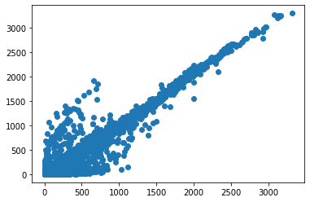

WITH Resources(vix,gold,crude_oil)

print(reg.score(x,y),mae,mse)

0.9595654044941849 53.64289135793368 7536.533853067281

Explained_var=-0.10291439853620465

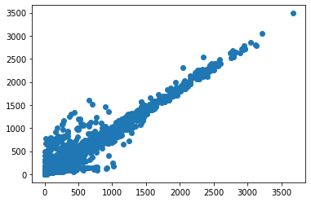

Metrics of MLP MODEL

REG_SCORE - 0.9735251090889137

Mean Absolute Error - 34.88984724242013

Mean Squared Error - 5425.483661827558

Explained_Variance_Score - 0.9735184766261576